Design of Train Tracking System

Yuval Rakavy

Goals
The Yuval Collection layout will be operated via LGB Multi-train system (MTS). The LGB program includes two types of sensors to detect the passing of locomotives:
- Track Contact – Those contacts can detect if a locomotive is passing it. However, the track contact does not identify which locomotive has passed over it.
- Train Detection Module – This module can detect whether a locomotive (or any other car that consume power) exist in a given track section. Like Track Contact, the detection module does not provide information on which locomotive was detected.
In order to control trains effectively, is necessary to know where each locomotive is. True, that the computer may control switch settings and locomotive motion speed and direction. However, the train tracking algorithm should not make use of this information since we would like to keep the option to manually control the above aspects of the layout operation.
This document describes an algorithm for train tracking. It will be implemented as part of the layout control manager software.

Layout Representation
The layout control manager software represents the layout in a schematic way. An example of an oval layout with a slide and a branch may look like:
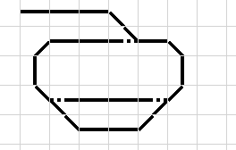
On this layout the user can overlay symbols for track contacts and track detection blocks:
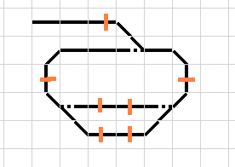
The track contacts define sections in the layout. A section is the connectable tracks that are bounded either by an end of track or a track contact. The above layout contains the six sections:
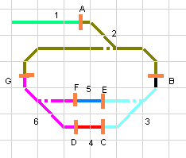
After designing the layout, the user switches between design mode and operation mode. If the layout is modified, the layout control manager performs a layout compilation phase. This phase consists of the following operations (probably it will do a bit more than what is described here):
- Check that each EPL drive (switches, traffic lights etc.) are assigned an address
- Making sure that the same address is not used twice
- And what is most relevant to our discussion, building a section graph.

The Section Graph
This data structure describes the sections and how they connect to each other. Basically it contains two entities: sections and track contacts. A section is connected to other sections via track contacts.
For example, the section graph for the above layout will look like:
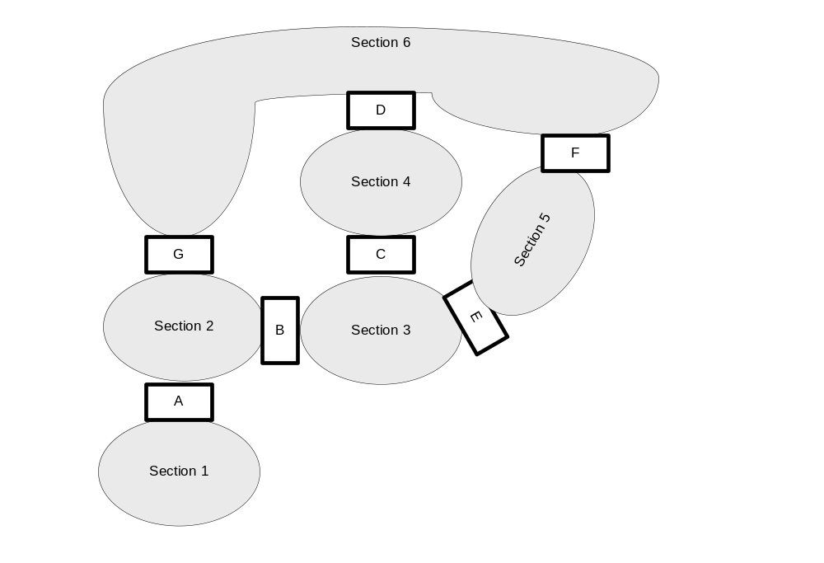
Each track-contact object holds references to the two sections that it is connecting. Each section contains a list of references to the track contacts that are connected to it.
In addition each section contains a list of the track components that are in this section, and each track holds a reference to the section containing it.

Building the Section Graph
This section describes the algorithm that is used to construct the section graph from the layout representation. This algorithm is run during the layout compilation phase.
TODO:

Tracking Locomotives
Before locomotive tracking can begin, the user has to specify the initial locomotive location. This is done by dragging the locomotive object from the locomotive list to a track. The locomotive will be positioned in the section that this track belongs to. The user is allowed to position only one locomotive in each section. Of course when the layout is operated there may be situation that more than one locomotive will be in a given section. Those situations are not desirable, and the way to handle them is described later.
Note, that the software does not know the exact location of a locomotive in the “section”. All that is known (if everything works) is what locomotives are in what sections.
Triggering a track contact indicate that a locomotive is moving from one section to another. The task in hand is to figure out which locomotive.
Let’s tackle the simple case first. This is the case where there is a single locomotive in only one of the sections that connects to the triggered contact. In this case it is easy to see that the track contact was triggered by this locomotive and it is moving from the section where it has been to the other section. For example, in the graphs presented above, say that track contact C is triggered. Section 3 contains locomotive M1 and section 4 is empty. In this case there is no ambiguity and it is clear that it was M1 that triggered the track contact and it moved from section 3 to section 4.
Almost all the other cases are ambiguous, and some educated guess will have to take place. It is obvious that these situations are not desirable, so the track contact location in the layout, and the layout signaling system should be designed to minimize those cases.

Handling Ambiguous Cases
Let divide those cases into the following classes:
- There is more than one locomotive in a sections
- There are locomotives in both sections that connect to the track contact.
Note that both cases can coexist, both sections can contain more than one locomotive.
As noted above, with proper layout design those cases should be very rare. The layout control manager will be able to detect those cases, and generate an alert. The user will be able to see the “guess” made by the control manager software, and will be able to fix it if it was incorrect.
Each locomotive object store the last crossed track contact, and a time stamp indicating when this crossing had happened.
The system will use the following rules:
If both sections have locomotives, the first step is to decide which section is the locomotive’s origin. The rule for this is:
- Assume that a locomotive is crossing from the section that is connected to smaller number of track contacts to a section that is connected to a larger number of track contacts.
The rational behind the above rule, is that if a section connects to more track contacts it consists of a more complex track layout which can probably accommodate more trains.
- If both sections connect to the same number of track contact, assume that the origin section is the one containing more locomotives.
- If both sections contain the same number of locomotives, assume that the origin section is the one containing the locomotive with the latest track-contact crossing time. The rational is to assume that the other trains are standing still.
After the origin section was selected, there is a need to guess which locomotive is crossing. Before stating the rules for this, let’s define the term linear section. If a section connected to more than two track contacts it is a non-linear section. Otherwise the section is linear (unless the user has specifically indicated that it is non-linear). In our example, sections 1, 4 and 5 are linear sections.
Since trains cannot bypass each other on a linear section, it is possible to determine which locomotive has triggered the track contact in a deterministic way.
As described above, each locomotive object stores the last track contact it has crossed and a time stamp indicating when this crossing was done. In order to determine the locomotive that has triggered the track contact at the end of a linear section the following rules are used:
- If there one or more locomotive that the last triggered track contact is the same as the current track contact, then the crossing locomotive is the one of this group with the latest time stamp. This is the scenario in which the locomotive crossed the track contact, then reversed its direction and crossed this track contact again.
- Otherwise, the locomotive that is triggering the track contact is the one with the earliest time stamp of crossing the previous track contact. Since this locomotive has crossed the other track contact first, it is the one closest to the current track contact.
If a non linear section contains more than one locomotive, the locomotive with the latest last cross time stamp is assumed. The reasoning behind this rule is that it is assumed that the other locomotive(s) is standing still.

It may be elected to save in the locomotive object a history of track contacts that this locomotive had crossed. This will allow tracking the locomotive route.

